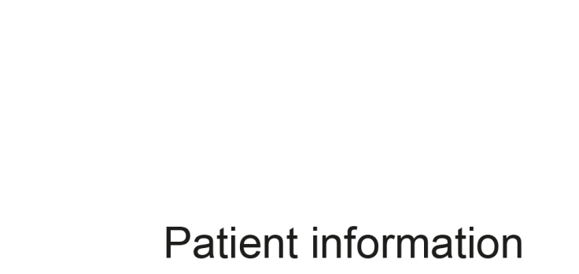
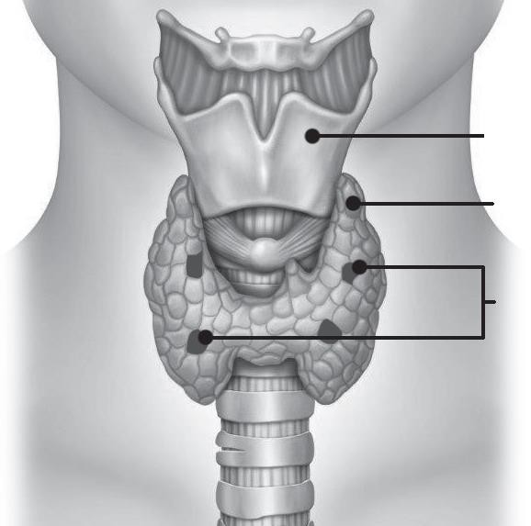


PI
1
V
3033

Parathyroidectomy
–

Parathyroid surgery

Endocrin
e

Surgery

Parathyroidectomy
–

Parathyroid surgery (Removal of one or more of the parathyroid
glands)
.

What are the parathyroid glands and what do they do?

Usually, you have four parathyroid glands; these glands are responsible for controlling
the calcium levels in the blood. They are usually located between the back of your
thyroid and your
windpipe, two on each side; they can be in other positions, occasionally
down into the chest. Parathyroid glands are usually three to four mm in size. They are
responsible for the production of the Parathyroid Hormone which is required for the
regulation o
f calcium in the body
.

Larynx

Adam’s apple

Thyroid gland

Parathyroid gland

Reasons why you may need a parathyroidectomy

One cause of high calcium in the body is due to an enlarged parathyroid gland which is ‘over- functioning’ producing too much Parathyroid Hormone (Primary Hyperparathyroidism PHPT).

In most patients this is due to a single abnormal parathyroid gland although occasionally more than one or all four glands that are involved.

Some symptoms of hyperparathyroidism may include:
o Tiredness and fatigue.
o Muscle weakness.
o Acid reflux.
o Urinary frequency.
o Thirst.
o Poor memory.
o Kidney stones.
o Fractures.
o Thinning of bones (osteopenia/osteoporosis).

o Pancreatitis.

What will happen if I don’t have surgery?

Your blood calcium levels would need to be monitored closely. If the levels become too high it is sometimes possible to have a medication to reduce the levels, however this is rarely prescribed. While it may lower the calcium it does not cure the condition.

What preparation will I need for surgery?

Usually for diagnosis you will have already provided blood samples and a urine sample. In order to find (‘localise’) the parathyroid glands you will have a SestaMIBI scan. This is a nuclear medicine scan to see if one or more of the glands are highlighted on the scan. An ultrasound scan will usually be undertaken following a SestaMIBI scan to confirm the position of the parathyroid gland(s).

Occasionally, these may highlight thyroid nodules which may need investigating with an Ultrasound or a biopsy.

Occasionally, parathyroid glands are not highlighted on a SestaMIBI scan or an ultrasound; this is not concerning as most will be found at surgery using a bilateral neck exploration technique. Occasionally further investigations may be undertaken.

All patients for surgery will attend a pre-operative assessment that can take most of the morning or the afternoon. This is performed by a specialist team and your fitness for an anaesthetic will be assessed with routine questions about your health, known allergies, medication, and a physical examination.

You may then have some tests, including blood tests, a heart trace, chest X-ray, and breathing studies (Pulmonary Function Tests).

If you have not already had an assessment of your voice box, this will be done by ENT at Aintree or Broadgreen Hospital. This will involve a quick camera test via the nose that does not need any preparation.

You will also be given instructions on eating and drinking before the operation and what medication to miss before the operation. You will be able to re-discuss the operation with the surgical team and go through the consent forms to ensure that you understand the procedure and the risks.

Your surgeon will also discuss with you the approach for surgery; this is usually a focused approach or bilateral neck exploration. If a parathyroid gland has been identified with the pre-operative scans, your surgeon may be able to target the parathyroid gland resulting in a smaller scar. A bilateral neck exploration will involve a
larger scar and attempt to look at all four parathyroid glands with the diseased gland(s) removed. Your surgeon may also discuss the use of intra-operative parathyroid hormone monitoring. This may be used for bilateral neck explorations to ensure the parathyroid hormone levels are reducing.

What are the risks of having a parathyroidectomy?

Hoarse voice/change in your voice

There is a small risk of damage or bruising to the nerve supply to the voice box, which can cause a change in the strength or tone of your speaking or singing voice. This is usually due to bruising and will recover over time, but can be permanent (1 in 100 cases) and, if this happens, you will be referred to see a speech and language specialist for treatment and support. If there is any change in your voice you will have a voice box check (as described previously) to assess whether there is any nerve injury.

The nerves are identified and protected if possible during the operation using nerve monitoring. Nerve monitoring involves placing a special to tube next to the vocal cords, partly for the anaesthetic, but also to allow the surgeon to test the nerve is working when they find it.

Infection

This can occur in any surgical wound but is not common in parathyroidectomy wounds. It would cause redness and pain around your scar and can increase the time it takes to heal. You may need antibiotics if this happens.

Bleeding/bruising

It is possible to have some minor bruising around your wound after surgery, but occasionally (less than 1 in 100 cases) excessive bleeding may cause a swelling in your neck which can cause a problem with your airway or breathing, and you may need to go back to theatre to stop the bleeding under anaesthetic. In the unlikely event that this does happen, it would generally be within the first 24 hours.

Scar

You will have a scar dependent on the type of surgery. The scar will look red to start with but will fade over the next two to three months. Some people are prone to developing a ‘keloid’ or ‘hypertrophic’ scar (raised and coloured) due to their skin type; it is unpredictable before surgery but sometimes may be improved at a later date. You will need to protect your scar from direct sunlight. It is advisable to use total sun block for at least the first three months.

Seroma

Swelling of the wound which develops gradually in the first two weeks after your operation can be due to simple fluid (a seroma). A small amount of fluid can build up under the wound in the first 24 hours and, to allow this to drain away, a small tube called a drain is sometimes placed at the time of surgery, which will be removed before you go home from hospital. If you develop a swelling later on, you need to contact the ward as it may need to be drained with a needle.

Calcium/Vitamin D supplements

You may require calcium or vitamin D supplements, if your calcium levels drop you may notice pins and needles/tingling in your fingers or around your mouth after your operation, and you will need a blood test done to check the calcium levels. A small proportion of patients may need calcium tablets for the rest of their life (2-5%).

Breathing problems

Damage or bruising to both nerves supplying the voice box is extremely rare (less than 1 in 1000 patients) but if this happens it may be necessary to put an artificial opening and small tube in the windpipe through the front of the neck (tracheostomy) to enable breathing.

Deep vein thrombosis (DVT)

This is a small risk after longer surgery that a blood clot in the leg veins may occur due to immobility. It is very important to move your legs while in bed and to get up and about as soon as possible.

You will need to wear some special stockings for six weeks after your surgery, and whilst you are in hospital you will be given a small injection daily to assist with keeping your blood thin.

Neck stiffness

You should move your head within your limits to prevent stiffness. You will be given an exercise leaflet to show you some simple exercises you can do.

Need for further surgery/failure to cure

Due to the location and size of the parathyroid glands sometimes the operation can fail to cure you. If this occurs you may need further investigation and further surgery. Your surgeon will talk to you about this if necessary at your post-operative clinic appointment or follow-up appointment.

There may also be risks or complications relevant to your particular case and the surgeon will discuss these with your before surgery where you can bring up any concerns you might have.

What sort of anaesthetic will be given to me?

You will be given a general anaesthetic. General anaesthesia is drug-induced unconsciousness: an anaesthetist, who is a doctor with specialist training, always gives it. You will meet your anaesthetist on the morning of surgery unless you require a specialist anaesthetic opinion, when you may meet them before the decision to operate is made.

A general anaesthetic is very safe but sometimes general anaesthetics can cause side effects and these can include nausea and vomiting. There is a risk of damage to teeth, particularly caps or crowns and veneers. Your anaesthetist will take every care, but occasionally damage can occur.

For more information, please ask for a copy of the Royal College of Anaesthetists leaflet : You and Your Anaesthetic.

If you are worried about any of these risks, please speak to your consultant or a member of their team.

The day of your operation

- You will come into hospital on the day of your operation.

- Please leave all cash and valuables at home. If you need to bring valuables into hospital, these can be sent to General Office for safekeeping. General Office is open between 8:30am and 4:30pm Monday to Friday. If you are discharged outside these times we will not be able to return your property until General Office is open. The Trust does not accept responsibility for items not handed in for safekeeping.

- Please bring any medication you take into hospital with you.

- Please bring in toiletries, nightwear, and towels.

- You will be asked to remove jewellery – plain band rings can be worn but they will be taped.

- Please leave body piercings at home.

- False nails and nail polish will also need to be removed if worn.

- If you are on regular medication, you will be told at the pre-operative assessment whether to take these on the morning of surgery.

- You will be asked to put on a gown and disposable underwear.

- A bracelet with your personal details will be attached to your wrist.

- You may be prescribed some medication to take before your operation by the anaesthetist. A member of the nursing staff will give this to you.

- A nurse and porters will take you to the operating theatre.

- Your dentures, glasses or hearing aid(s) can stay with you on your journey to the operating theatre.

- When you arrive in the theatre area, the ward nurse will leave you, and you will be asked to put on a disposable hat.

- You will then be taken to the anaesthetic room and a member of theatre staff and a member of your surgical team will check your details with you.

What should I expect after my operation?

- After your operation you will be kept in the theatre recovery room before being transferred to the ward.

- A nurse will check your pulse, blood pressure, and breathing rate regularly.

- It is important that if you feel any pain you tell the nursing staff, who can give you painkillers to help.

- You may have a drip (cannula/intravenous line) in your hand or arm with some fluids running through it.

- The nursing staff will also advise you when you can start taking sips of water. If you feel sick, please tell the nursing staff who can give you an injection to help this sick feeling go away.

- Blood tests will be repeated before you leave the ward to check calcium levels.

- Replacement therapy (tablets) will discussed with before discharge if necessary.

- The first time you get out of bed, please make sure you ask a nurse to be with you. This is in case you feel dizzy.

Discharge

You will be discharged home when the doctor is happy with you. This will usually be around lunchtime the next day.

You will be given painkillers to take home. Please tell the nurses what painkilling tablets you have at home.

Please ensure your wound is kept clean and dry. Avoid the use of make-up and perfumed creams. You will have a stitch to your wound which will be removed in clinic on the Thursday two weeks after your surgery.

Getting back to normal

Remember that you have just had an operation. It is normal to feel more tired than usual for a few days afterward.

Returning to work

If you need a fit note, please ask for this before discharge. This is normally for two weeks but may depend on your occupation.

Follow-up appointment

You will be given an appointment to attend clinic on the Thursday two weeks following your surgery. You will need to have blood tests taken two days before your clinic appointment.

Patient notes:

………………………………………………………………………………………………………………………………………………………………………………………………………………………………………………………………………………………………………………………………………………………………………………………………………………………………………………………………………………………………………………………………………………………………………………………………………………………………………………………………………………………………………………………………………………………………………………………………………………………………………………………………………………………………………………………………………………………………………………………………………………………………………………………………………………………………………………………………………………………………………………………………………………………………………………………………………………………………………………………………………………………………………………………………………………………………………………………………………………………………………………………………………………………………………………………………………………………………………………………………………………………………………………………………………………………………………………………………………………………………………………………………………………………………………………………………………………………………………………………………………………………………………………………………………………………………………………………………………………………………
Feedback

Your feedback is important to us and helps us influence care in the future.

Following your discharge from hospital or attendance at your outpatient appointment you will receive a text asking if you would recommend our service to others. Please take the time to text back, you will not be charged for the text and can opt out at any point. Your co-operation is greatly appreciated.

Further information

Consultant Endocrine Surgeons:

Miss S. Shore
Miss A. J. Waghorn
Secretary: Shirley Cottenden
Tel: 0151 706 3412
Text phone number: 18001 0151 706 3412

Mr M. P. Rowland
Secretary Sarah McGee
Tel: 0151 706 3459
Text phone number: 18001 0151 706 3459

Specialist Endocrine Surgery Nurse:
Rachael Ireland
Tel: 0151 706 5107
Text phone number: 18001 0151 706 5107

British Association of Endocrine and Thyroid Surgeons
(BAETS) www.baets.org.uk

Author: Endocrine Surgery – Royal Liverpool Hospital
Review Date: July 2029

